**Assignment no 2**

**Experiment No.1**

#### OBJECTIVE:

Write a program to add two hexadecimal numbers.

#### Statement:

add two number 05H and 13H and display result in output port 18H.

#### Steps:

* The MVI command moves the 05H and 13H to their respective destination A and B.
* Store the added number (new number) and display in the output port 18H.
* Terminate the program.

## Program: -

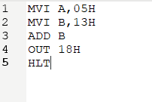

**Register: -**

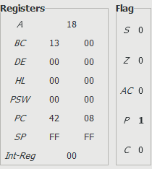

**Output port:-**

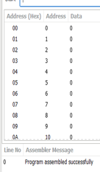

**Experiment 2**

**Objectives**

Write a program to add two 8-bit hexadecimal numbers.

**Statement:**

Add numbers from memory location 2050H & 2051H and store result in memory location 2055H.

**Steps:**

* Load the data from the memory location 2051H
* Transfer the data
* Load to accumulator
* Store in 2055H memory location

## Program:

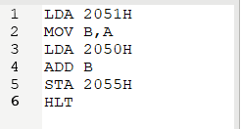

**Register:**

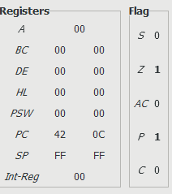

**Output port:**

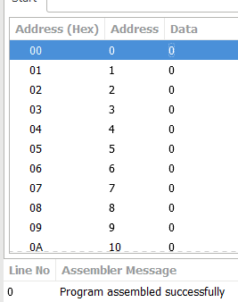

**Experiment 3**

**Objectives**

Subtract numbers 25H & 12H and display result in output port o01H.

## Steps:

* Transfer the data from memory location 25H and 12H respectively in A and B.
* Subtract
* Store the subtracted number (new number) in 01H port.

## Program:

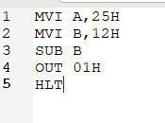

**Register:**

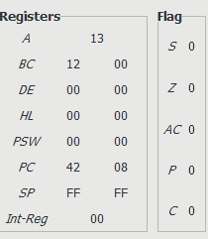

**Output port:**

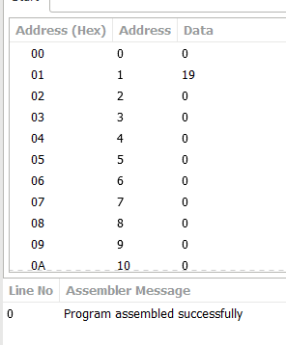

**Experiment 4**

**Objectives**

Write a program to subtract two 8-bit numbers.

## Statement:

Subtract numbers from memory location 2050H & 2051H and store result in memory location 2055H.

## Steps:

* Same as Experiment 1 (only difference is the addition and subtraction).

## Program:

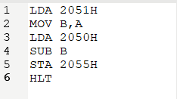

**Register:**

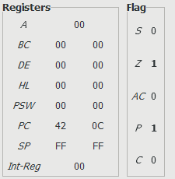

**Output port:**

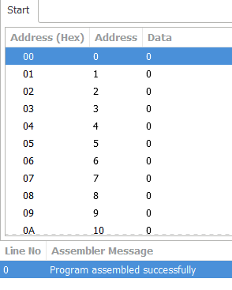

**Experiment 5**

**Objectives**

Write a program to find 1’s complement of a number.

## Statement:

Input number from memory location 2013H and store result in memory location 2055H.

## Steps:

* Transfer data from memory location 2013H to Accumulator.
* Complement the contents in the accumulator.
* Store in 2052H memory location.

## Program:

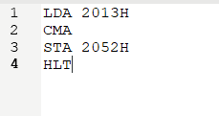

**Register:**

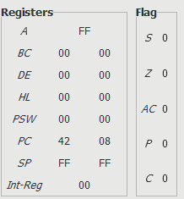

**Output port:**

